Joe Huffer

CSD 310

Professor Sampson

6/16/2024

Module 5.2 – BioSite: Ideas, Sketches, and Inspiration.

**Style Guide**

Using <https://paulrobertlloyd.com/styleguide/> as a guide, I’ve selected the following coloring schema – I will break it down so that each section will be manageable in future modules (and so that I don’t forget):  
  
Regarding Color Palette Specifically this week:

Primary Color: Yellow (#FFD700) – Interviewers favorite color was yellow. Thought yellow would be fun for links and quote borders

Secondary Color: Olive Drab (#6B8E23) – My interviewee likes the color “olive green” – use for line breaks or texts within quotes/comments.

Background Color: Light Grey (#F0F0F0): Almost always select a very light gray (almost white) for my backgrounds.

Text Color: Dark Grey (#333333): a Dark gray, almost black, pairs well with the whiteness of the background. Can also maybe use #000000 (Black)

Accent Color: Dark Red (#8B0000): 8B0000 is a dark red – thought of adding this as an accent color for emphasis on headings or important text.

**Wireframe:**

**Wireframe Sketches**

**Landing Page**

Main introduction to the interviewed individual (Courtney Huffer, Relation: Wife), I’m thinking somewhat of a creative header on who she is based on the interview and what others had to say , followed by a revision of the introduction I’ll type out.

1. **Header**: Title of the website, navigation links to “Home”, "About", and "Hobbies" sections.
2. **Main Section**:
   * **Portrait Image**: See images folder within github/local – best image Courtney selected of herself.
   * **Introduction Text**: A brief introduction with a few sentences about Courtney.
   * **Links**: Buttons or links to "Read More" about Courtney, her hobbies, and contact information.
3. **Footer**: Can include dummy buttons of social media links or potentially places of business – her new grooming salon if she is okay with it!

**About Page**

The about page will give a detailed biography of Courtney, using the information we've compiled.

1. **Header**: Same header as previous section.
2. **Main Section**:
   * **Portrait Image**: Smaller version of the portrait image from the landing page. Can use the same image.
   * **Biography Text**: The 250-word biography.
3. **Footer**: Same as the landing page.

**Hobbies Page**

The hobbies page will showcase Courtney's hobbies with images and descriptions.

1. **Header**: Same header as previous sections.
2. **Main Section**:
   * **Hobbies Section**:
     + **Image and Description**: Image of dog grooming or dock diving. Pictures of Garden. Pictures of Quails/QuailCoop. So three sections, with image and captioned info.
3. **Footer**: Same as the landing page.

**Wireframes (3 drawn images based on previous descriptions: “Landing” Page, “About” Page, and “Hobbies” page)**

Landing Page

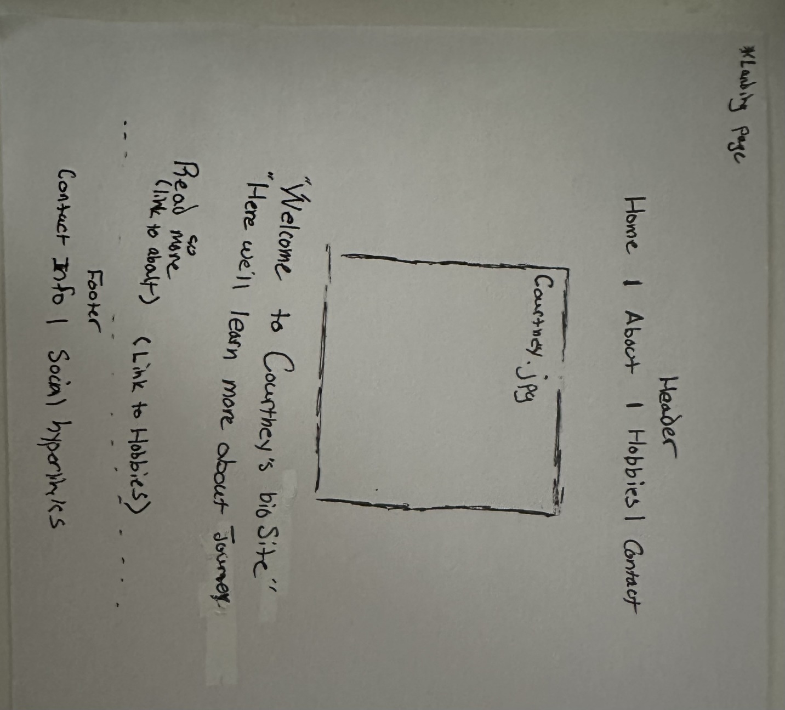

About Page

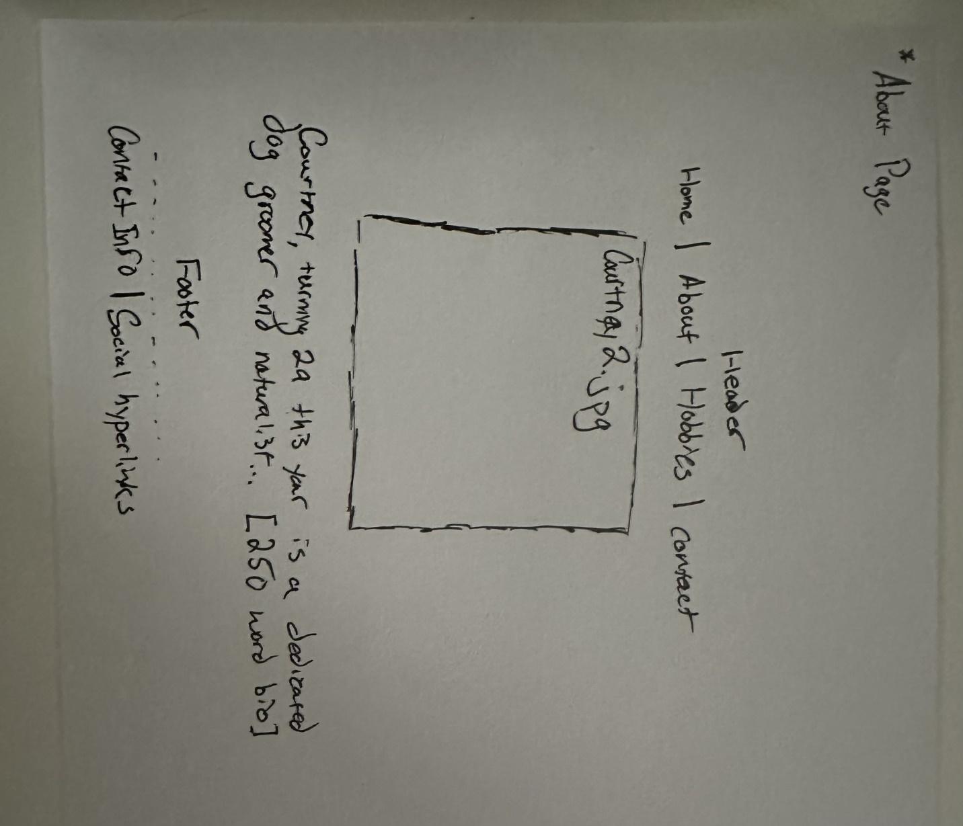

Hobbies Page

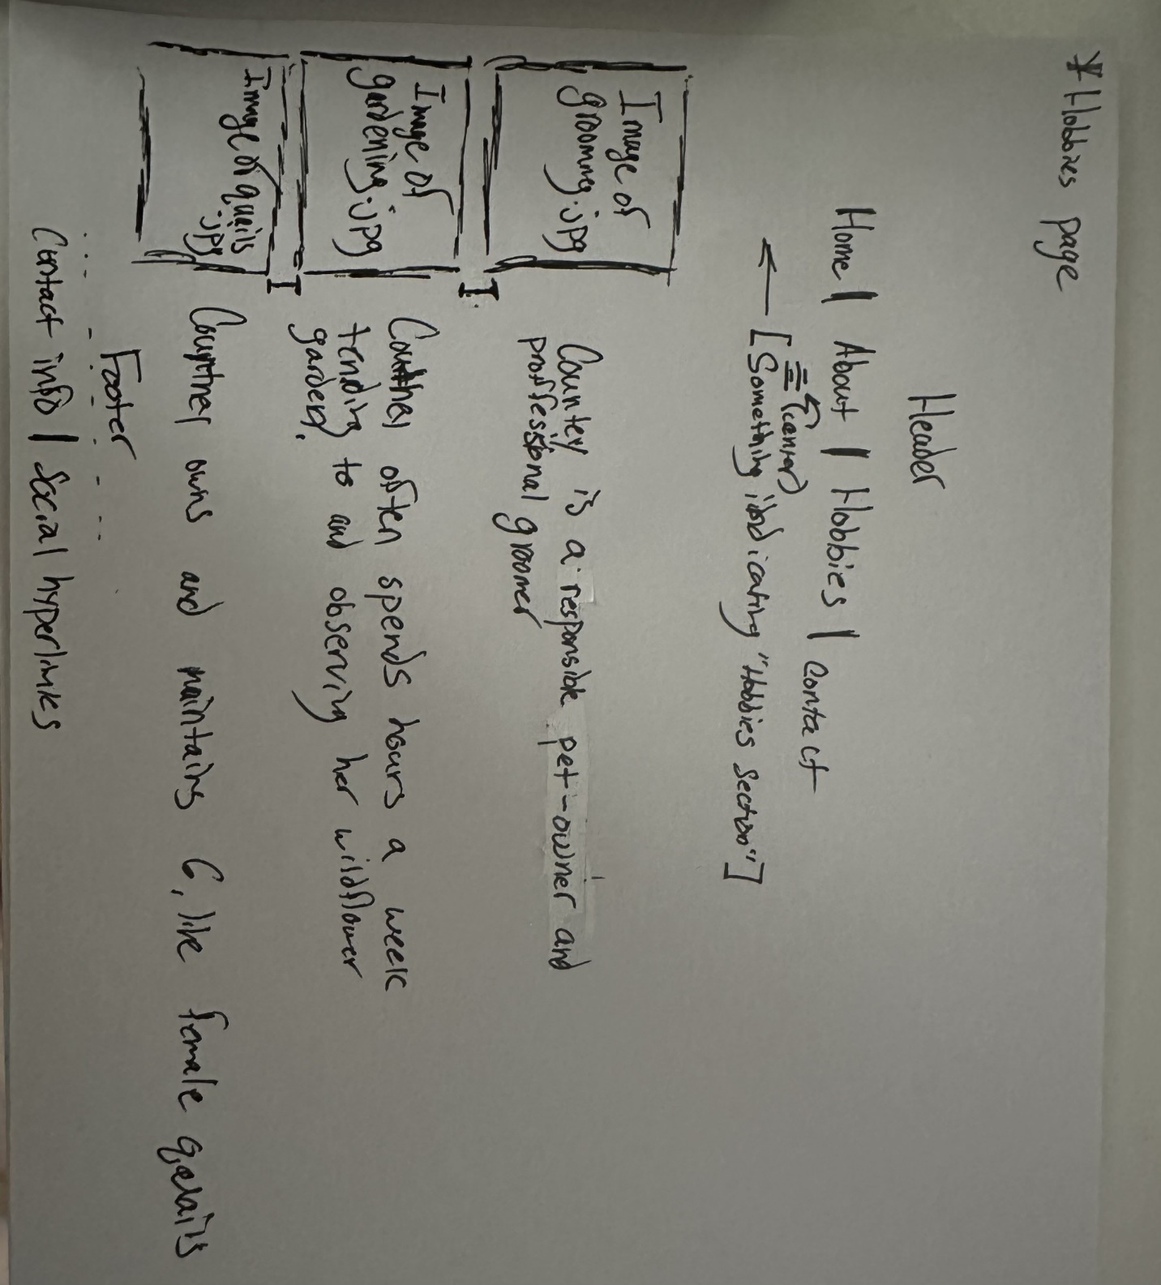

**Interview Questions**

**Interviewee: Courtney Huffer, 28, Female, Dog Groomer and Wife**

**Can you tell me about your childhood and where you grew up?**

* I grew up in Springfield, Ohio. My childhood was filled with animals, as my parents raised farm animals for recreation (2 Donkeys, 10+ chickens, Pigs, Goats). This nurturing environment sparked my lifelong passion for caring for living creatures and ultimately led me to study them in depth. My parents were helicopters at times, but they also pushed me to follow my dreams, as long as they were healthy and well-thought out.

**What are some of your most significant accomplishments?**

* One of my most significant accomplishments was my research work during college at Otterbein, where I worked with Hellbenders to enhance their predatory response to benefit their species survival. Additionally, I had a brief but rewarding career as a zookeeper for Gorillas and am now an awarded dog groomer. I’m also part of the Poodle Club of America and have published papers in animal science. Another, and it may sound cheesy, is that I met my husband there. ‘[he/you] taught me that I can truly be myself, and that if I don’t desire to do something, I can simply choose not to”

**What hobbies are you passionate about, and why?**

* I am passionate about animal grooming, especially for my own dogs who take about 5 hours a week on average, gardening in my wildflower garden, and taking care of my quails (We have 6 now! All girls.). I also love reading and staying healthy through yoga, Pilates, and a balanced diet. These activities bring me joy and a sense of accomplishment.

**How did you get started with your hobbies?**

* My love for animals began with my parents’ farm, where I learned to nurture and care for living things. This extended to my studies and professional work, and eventually, I found a niche in dog grooming. My interest in gardening started as a way to connect with nature, and it has grown into a relaxing and fulfilling hobby even though our garden can get out of hand at times.

**What are your current goals or aspirations?**

* My current goal is to step away from the professional world and focus on becoming a mother. Right now it’s the most important thing to me, and I am taking steps to prepare for this new chapter in my life.

**Can you describe a typical day in your life?**

* I start my day with a workout, usually yoga or Pilates, followed by a healthy breakfast and my daily vitamins and supplements. I create a list of tasks and set out to accomplish them, whether it’s grooming dogs, taking care of my garden, or spending time with family. I also make sure to allocate time for relaxation and self-care.

**What is a memorable moment that has shaped who you are?**

* One memorable moment was when my research on Hellbenders was published. It was a culmination of my hard work and passion for animal science, and it reinforced my commitment to making a difference in the lives of animals. Plus I had a pretty empowering sense that I was helping an animal species continue to survive by teaching them to be more scared of predator noises and queues.

**How do you spend your free time?**

* In my free time, I groom my dogs—Geralt, Zero, and Arya—spend time in my wildflower garden, take care of my quails, read, and occasionally doom-scroll on Facebook. I also enjoy spending quality time with my family and husband going on hikes.

**What values are most important to you?**

* The values most important to me are Loyalty and Honesty. I also believe in caring deeply for others, whether they are animals or people and that balance between the two, working hard to achieve my goals, and always being open to new knowledge and experiences.

**What advice would you give to your younger self?**

* I would tell my younger self to be less critical and to not let the high standards of others cause unnecessary stress. While those standards helped me excel academically and professionally, it's important to find a balance and be kind to oneself. I’d also reinforce that I am my own person and make sure I understand and value that autonomy.

**Biography:**

Courtney Huffer: From Zoo Keeper, to Beloved Groomer

Courtney Huffer, 28, grew up in Springfield, Ohio, in a very stable environment with her loving parents Bob and Linda Dover. While surrounded by farm animals, this ignited her passion for animal care. Her parents pushed her to pursue her dreams, leading her to study at Otterbein University. There, she conducted significant research on Hellbenders, enhancing their predatory response to benefit species survival. This research was published, marking one of her proudest accomplishments to date. Additionally, Courtney had a brief but rewarding career as a zookeeper for Gorillas and is now an awarded dog groomer and a member of the Poodle Club of America.

Courtney's hobbies include grooming her dogs (Geralt, Zero, and Arya) as well as others, gardening in her wildflower garden, and taking care of her six quails. She also enjoys reading and staying healthy through yoga, Pilates, and a balanced diet. These activities make her feel full and give her a sense of accomplishment. Her love for animals began with her parents' farm and extended to her studies and professional work, eventually finding a niche as a successful dog groomer.

Currently, Courtney's primary goal is to step away from the professional world and focus on becoming a mother (no announcement yet **note she wanted me to mention that). She starts her days with a workout, followed by a healthy breakfast and daily vitamins. Her days are filled with tasks like grooming dogs, gardening, and spending time with her family. In her free time, she enjoys hikes with her husband, reading, and occasional doom-scrolling on Facebook.

Courtney values loyalty, honesty, and the balance between caring for animals and people. She believes in working hard to achieve her goals and always being open to new experiences. Her advice to her younger self is to be less critical and embrace autonomy, understanding the importance of being kind to oneself.

Images (Images are located in module 5 folder also: C:\csd\csd-340\module-5\images):

**Portrait1.jpg**

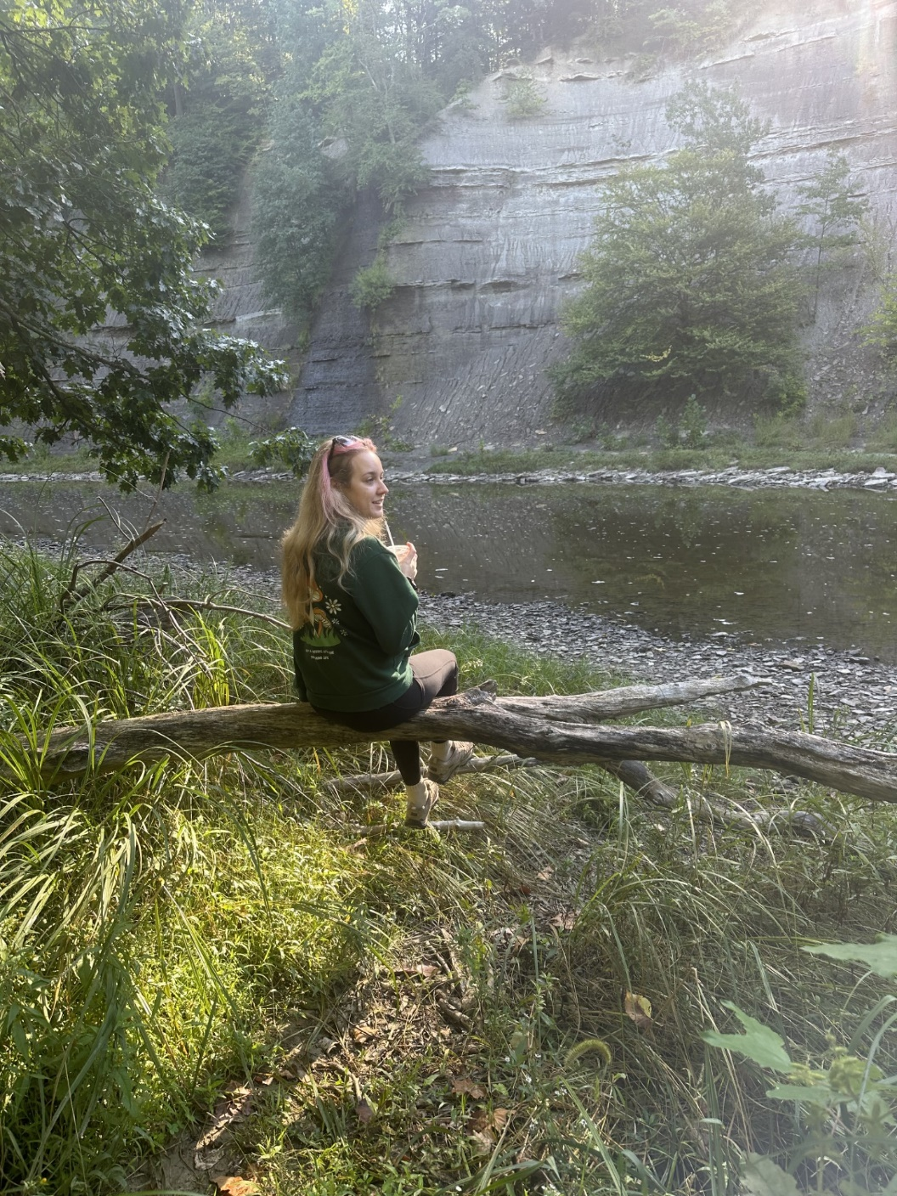

**Portrait2.jpg**

**Imageofgrooming.jpg**

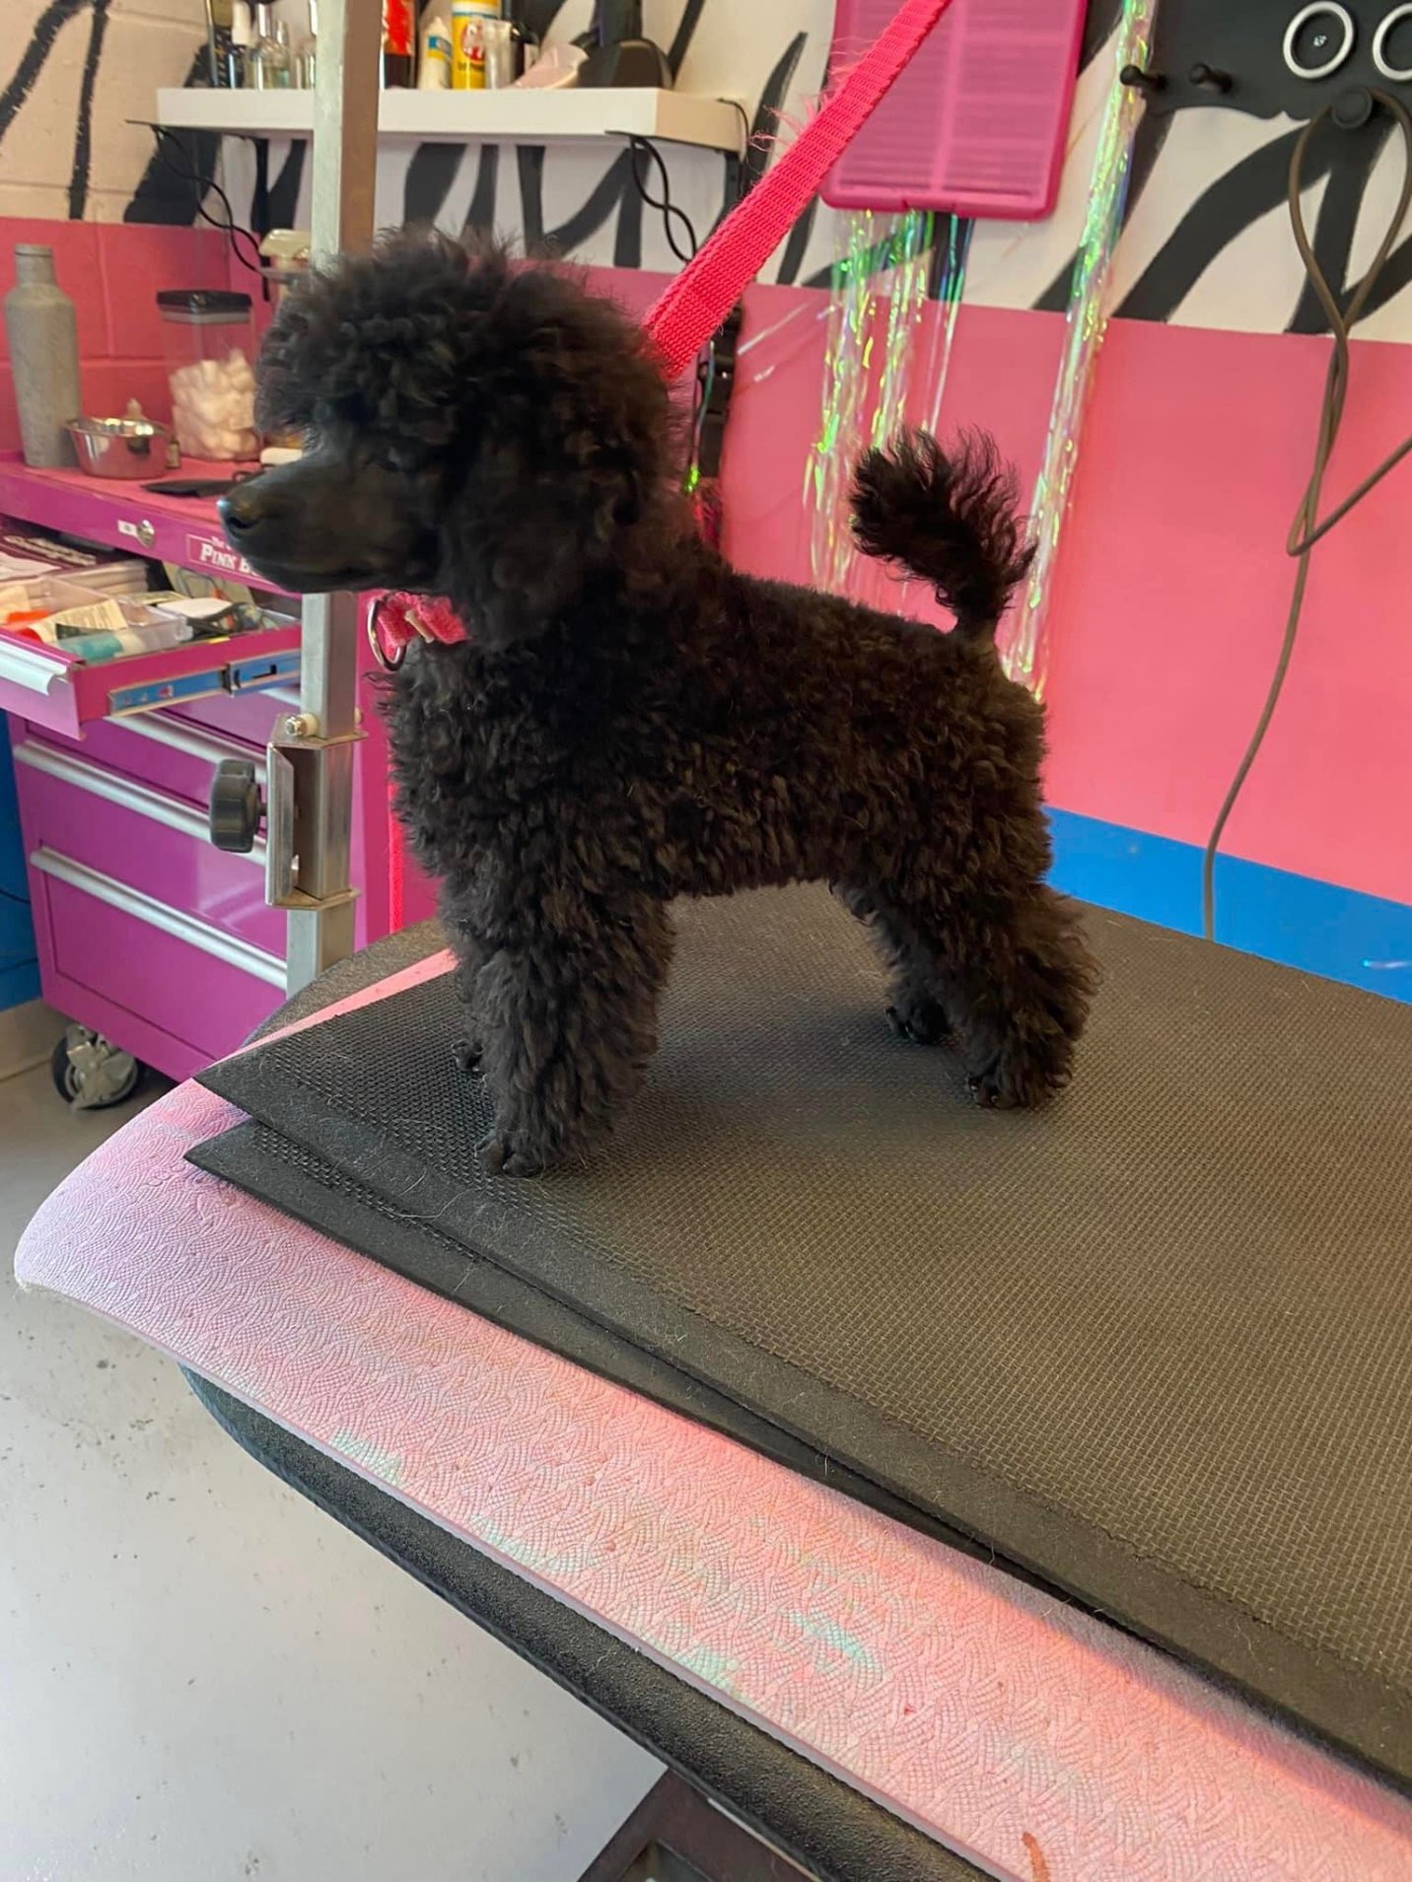

**Imageofgardening.jpg**

**Imageofquails.jpg**

